




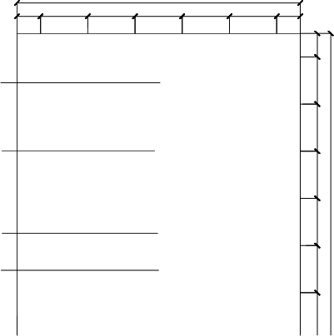
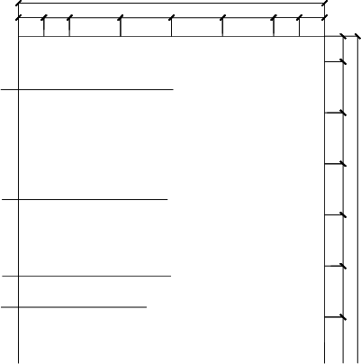


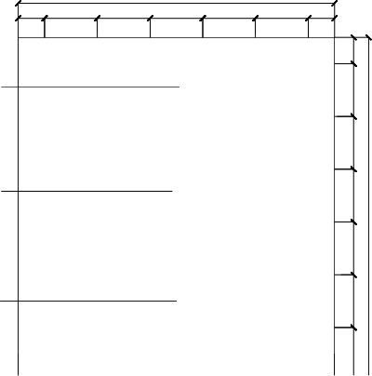



R487,5
270 300 300 300 300 300 150
1920
1800
150 300 300 300 300 300 150
白色瓷砖
黄色瓷砖
黑色瓷砖
白色瓷砖
120
60
120
270 300 300 300 300 300 150
1920
1800
150 150 300 300 300 300 150 150

白色瓷砖
橙色瓷砖
黄色瓷砖
白色瓷砖
300 100
220
270 300 300 300 300 300 150
1920
1800
150 300 300 300 300 300 150
白色瓷砖
红色瓷砖
白色瓷砖
35°

 | 165 | 150 | 150 | 165

100
100
100
5
R75
75
100
100
100
100
150
6
0°
90°
60°
60°
150
10050
R50

墙面  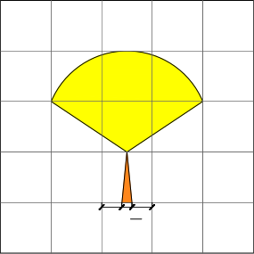 |  |  |  |  |  |  |  |  |  |  |  |  |  |  |  |  |  |  |  |  |  |  | 墙面 |  |  |  |  |  |  |  |  |  |  |  |  |  |  |  |  |  |  |  |  | 墙面
  150
地面  橙色瓷砖  黄色瓷砖  白色瓷砖 |  |  |  |  |  |  |  |  |  |  |  |  |  |  |  |  |  |  |  |  | 1200 |  | 地面  黄色瓷砖  橙色瓷砖  白色瓷砖 |  | 50 |  |  |  |  |  |  |  |  |  |  |  |  |  |  |  |  | 1200 |  | 地面  黄色瓷砖  白色瓷砖 |  | 50 |  |  |  |  |  |  |  |  |  |  |  |  |  |  |  |  |  | 1200
 |  |  |  |  |  |  |  |  |  |  |  |  |  |  |  |  |  |  |  | 150 |  |  |  |  |  | R1 |  |  |  |  |  |  |  |  |  |  |  |  |  |  | 150 |  |  |  |  |  | R1 |  |  |  |  |  |  |  |  |  |  |  |  |  |  |  | 150 | 1200
 |  |  |  |  |  |  |  |  |  |  |  |  |  |  |  |  |  |  |  | 150 |  |  |  |  |  |  |  |  |  |  |  |  |  |  |  |  |  |  |  |  | 150 |  |  |  |  |  |  |  |  |  |  |  |  |  |  |  |  |  |  |  |  |  | 150 | 1200
 |  |  |  |  |  |  |  | 75 |  |  |  |  |  |  |  |  |  |  |  | 150 |  |  |  |  |  |  |  |  |  |  |  |  |  |  |  |  |  | 00100 |  |  | 150 |  |  |  |  |  |  |  |  | 75 |  |  |  |  |  |  |  |  |  |  |  |  | 150 | 1200
 |  |  |  |  |  |  |  |  |  |  |  |  |  |  | 7 |  |  |  |  | 150 |  |  |  |  |  |  |  |  |  |  |  |  |  |  |  |  |  | 1001 |  |  | 150 |  |  |  |  |  |  |  |  |  |  |  |  |  |  |  |  |  |  |  |  |  | 150 | 1200
 |  |  |  |  |  |  |  |  |  |  |  |  |  |  |  |  |  |  |  | 150 |  |  |  |  |  |  |  |  |  |  |  |  |  |  |  |  |  |  |  |  | 150 |  |  |  |  |  |  |  |  |  |  |  |  |  |  |  |  |  |  |  |  |  | 150 | 1200
 |  |  |  |  |  |  |  |  |  |  |  |  |  |  |  |  |  |  |  | 150 |  |  |  |  |  |  |  |  |  |  |  |  |  |  |  |  |  |  |  |  | 150 |  |  |  |  |  |  |  |  |  |  |  |  |  |  |  |  |  |  |  |  |  | 150 | 1200
 |  |  |  |  |  |  |  |  |  |  |  |  |  |  |  |  |  |  |  | 100 |  |  |  |  |  |  |  |  |  |  |  |  |  |  |  |  |  |  |  |  | 100 |  |  |  |  |  |  |  |  |  |  |  |  |  |  |  |  |  |  |  |  |  | 100 | 1200
 | 150 | 150 | 150 |  | 150 |  | 150 |  | 150 |  |  |  | 150 |  | 150 | 150 |  | 150 | 150 |  |  |  |  | 150 | 150 | 150 | 150 |  | 150 | 150 | 150 |  | 150 |  | 150 | 150 |  | 150 |  | 150 |  |  |  |  | 150 | 150 | 150 | 150 | 150 |  | 150 |  | 150 |  | 150 |  | 150 |  | 150 |  | 150 | 150
 | 1800 |  |  |  |  |  |  |  |  |  |  |  |  |  |  |  |  |  |  |  |  |  |  | 1800 |  |  |  |  |  |  |  |  |  |  |  |  |  |  |  |  |  |  |  |  | 1800
墙地面示意图 1：20 |  |  |  |  |  |  |  |  |  |  |  |  |  |  |  |  |  |  |  |  |  |  | 墙地面示意图 1：20 |  |  |  |  |  |  |  |  |  |  |  |  |  |  |  |  |  |  |  |  | 墙地面示意图 1：20
一级难度: 墙、地平面无造型，图案简单~直线/斜线/一层圆、弧切割









R50
R150
200 100
1800

白色瓷砖
粉色瓷砖
白色瓷砖
粉色瓷砖
7575 7575
100
120° 90
90

 | 130 170 |  |  |  |  | 170 130
°

°
 | 130 | 170 | 300 |  |  | 170 | 130

150 300 300 300 300 300 150

0
300
300
3
120°
300
300
300
300
100
130 170 300

170 | 130

100
100
100
R50
100
100
50
R75
75
00
100
150
150
150
150
150
150
50
100
100
100
150
150
150
R75

墙面 |  |  |  |  |  |  |  |  |  |  |  |  |  |  |  |  |  |  |  |  | 墙面  白色瓷砖  粉色瓷砖  白色瓷砖  粉色瓷砖 | 1800 |  |  |  |  |  |  |  |  |  |  |  |  |  |  |  |  |  |  | 墙面  白色瓷砖  粉色瓷砖  白色瓷砖  粉色瓷砖 | 1800
 |  |  |  |  |  |  |  |  |  |  |  |  |  |  |  |  |  |  |  |  |  | 150 300 300 300 300 300 150 |  |  |  |  |  |  |  |  |  |  |  |  |  |  |  |  |  |  |  | 150 300 300 300 300 300 150
 |  |  |  |  |  |  |  |  |  |  |  |  |  |  |  |  |  | 150 | 1920 |  |  |  |  |  |  |  |  |  |  |  |  |  |  |  |  |  |  | 150 | 1920 |  |  |  |  |  |  |  |  |  |  |  |  |  |  |  |  |  |  |  |  |  |  | 150 | 1920
 |  |  |  |  |  |  |  |  |  |  |  |  |  |  |  |  |  | 300 |  |  |  |  |  |  | 130 170 |  |  |  |  |  | 170 130 |  |  |  |  |  |  | 300 | 1920 |  |  |  |  |  |  |  |  |  |  |  |  |  |  | 170 130 |  |  |  |  |  |  |  | 300 | 1920
 |  |  |  |  |  |  |  |  |  |  |  |  |  |  |  |  |  |  |  |  |  |  |  |  |  |  |  |  |  |  |  |  |  |  |  |  |  |  |  |  |  |  |  |  |  | 130 170
 |  |  |  |  |  |  |  |  |  |  |  |  |  |  |  |  |  |  |  |  |  |  |  |  |  |  |  |  |  |  |  |  |  |  |  |  |  |  |  |  |  |  |  |  |  |  |  |  |  | 120°
 |  |  |  |  |  |  |  |  |  |  |  |  |  |  |  |  |  | 300 |  |  |  |  |  |  |  |  |  |  |  |  |  |  |  |  |  |  |  | 300 |  |  |  |  |  |  |  |  |  |  |  |  |  |  |  |  |  |  |  |  |  |  |  | 300 | 1920
 |  |  |  |  |  |  |  |  |  |  |  |  |  |  |  |  |  | 300 |  |  |  |  |  |  |  |  |  |  |  |  |  |  |  |  |  |  |  | 300 |  |  |  |  |  |  |  | 130 170 |  |  |  | 300 |  |  |  | 170 |  | 130 |  |  |  |  |  | 300 | 1920
 |  |  |  |  |  |  |  |  |  |  |  |  |  |  |  |  |  | 270 | 1920 |  |  |  |  |  |  |  |  |  |  |  |  |  |  |  |  |  |  | 270 | 1920 |  |  |  |  |  |  |  |  |  |  |  |  |  |  |  |  |  |  |  |  |  |  | 270 | 1920
地面  黄色瓷砖  粉色瓷砖  白色瓷砖 |  | 50 |  |  |  |  |  |  |  |  |  |  |  |  |  |  |  |  | 1200 |  | 地面  粉色瓷砖  白色瓷砖 |  |  |  |  |  |  |  |  |  |  |  |  |  |  |  |  |  | 1200 |  | 地面  黄色瓷砖  粉色瓷砖  白色瓷砖 |  | 50 |  |  |  |  |  |  |  |  |  |  |  |  |  |  |  |  |  |  |  | 1200
 |  |  | R1 |  |  |  |  |  |  |  |  |  |  |  |  |  |  | 150 |  |  |  |  | 50 |  |  |  |  |  |  |  |  |  |  |  |  |  |  | 150 |  |  |  |  |  | R1 |  |  |  |  |  |  |  |  |  |  |  |  |  |  |  |  |  | 150 | 1200
 |  |  |  |  |  |  |  |  |  |  |  |  |  |  |  |  |  | 150 |  |  |  |  |  |  |  |  |  |  |  |  |  |  |  |  |  |  |  | 150 |  |  |  |  |  |  |  |  |  |  |  |  |  |  |  |  |  |  |  |  |  |  |  | 150 | 1200
 |  |  |  |  |  |  |  |  |  |  |  |  |  |  | 100 |  |  | 150 |  |  |  |  |  |  |  |  |  |  |  |  |  |  |  |  |  |  |  | 150 |  |  |  |  |  |  |  |  |  |  | 75 |  |  |  |  |  |  |  |  |  |  |  |  | 150 | 1200
 |  |  |  |  |  |  |  |  |  |  |  |  |  |  | 1001 |  |  |  | 1200 |  |  |  |  |  |  |  |  |  |  |  |  |  |  |  |  |  |  |  |  |  |  |  |  |  |  |  |  |  |  |  |  |  |  |  |  |  |  |  |  |  |  |  | 1200
 |  |  |  |  |  |  |  |  |  |  |  |  |  |  |  |  |  | 150 |  |  |  |  |  |  |  |  |  |  |  |  |  |  |  |  |  |  |  | 150 |  |  |  |  |  |  |  |  |  |  |  |  |  |  |  |  |  |  |  |  |  |  |  | 150 | 1200
 |  |  |  |  |  |  |  |  |  |  |  |  |  |  |  |  |  | 100 |  |  |  |  |  |  |  |  |  |  |  |  |  |  |  |  |  |  |  | 100 |  |  |  |  |  |  |  |  |  |  |  |  |  |  |  |  |  |  |  |  |  |  |  | 100 | 1200
 | 150 | 150 | 150 | 150 | 150 | 150 |  | 150 |  | 150 | 150 |  | 150 |  | 150 |  | 150 |  |  |  |  | 150 | 150 | 150 | 150 |  | 150 |  |  | 150 | 150 |  |  |  |  | 150 | 150 |  |  |  |  | 150 | 150 | 150 |  | 150 |  | 150 |  | 150 |  | 150 |  | 150 |  | 150 |  | 150 |  | 150 | 150
 | 1800 |  |  |  |  |  |  |  |  |  |  |  |  |  |  |  |  |  |  |  |  | 1800 |  |  |  |  |  |  |  |  |  |  |  |  |  |  |  |  |  |  |  | 1800
墙地面示意图 1：20 |  |  |  |  |  |  |  |  |  |  |  |  |  |  |  |  |  |  |  |  | 墙地面示意图 1：20 |  |  |  |  |  |  |  |  |  |  |  |  |  |  |  |  |  |  |  | 墙地面示意图 1：20
二、三级难度: 图案较复杂~直线/斜线/2~3层圆、弧切割

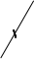
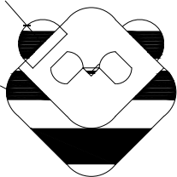



225
225
300
R100
R150
R345
R125
R187,5
300 150
300 150
R188
300 150
150
300 300 300
1920
960
300 300 300
1920
50
100100
300 300 300
1920
100 150 150 150 150 150 150 100100 270 300
1200
100 150 150 150 150 150 150 100100 270 300
1200
50
25
50
50
100 150 150 150 150 150 150 100100 270 300
1200
R150
R150
150
150
R30
R150
黑色瓷砖
白色瓷砖
白色瓷砖
10
1050

墙面

墙面
墙面

1800
1800
300
1800
300
300
300 150
300
300
150 300
300
300 150
150
300
300
300 150
150
300
300
300

白色瓷砖
白色瓷砖
白色瓷砖

黑色瓷砖
黑色瓷砖
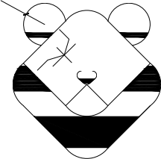
R30
R187,5

黑色瓷砖 黑色瓷砖 黑色瓷砖

白色瓷砖

地面
地面
地面
50150
150
50

100
黑色瓷砖
绿色瓷砖

50 50
黑色瓷砖
绿色瓷砖

白色瓷砖
黑色瓷砖
白色瓷砖
白色瓷砖

150 150 150 150 150 150 150 150 150 150 150
150 150 150 150 150 150 150 150 150 150 150
1800
150 150 150 150 150 150 150 150 150 150 150
1800
1800

墙地面示意图 1：20 墙地面示意图 1：20 墙地面示意图 1：20

四、五级难度:图案较复杂~直线/斜线/2~3层圆、弧切割

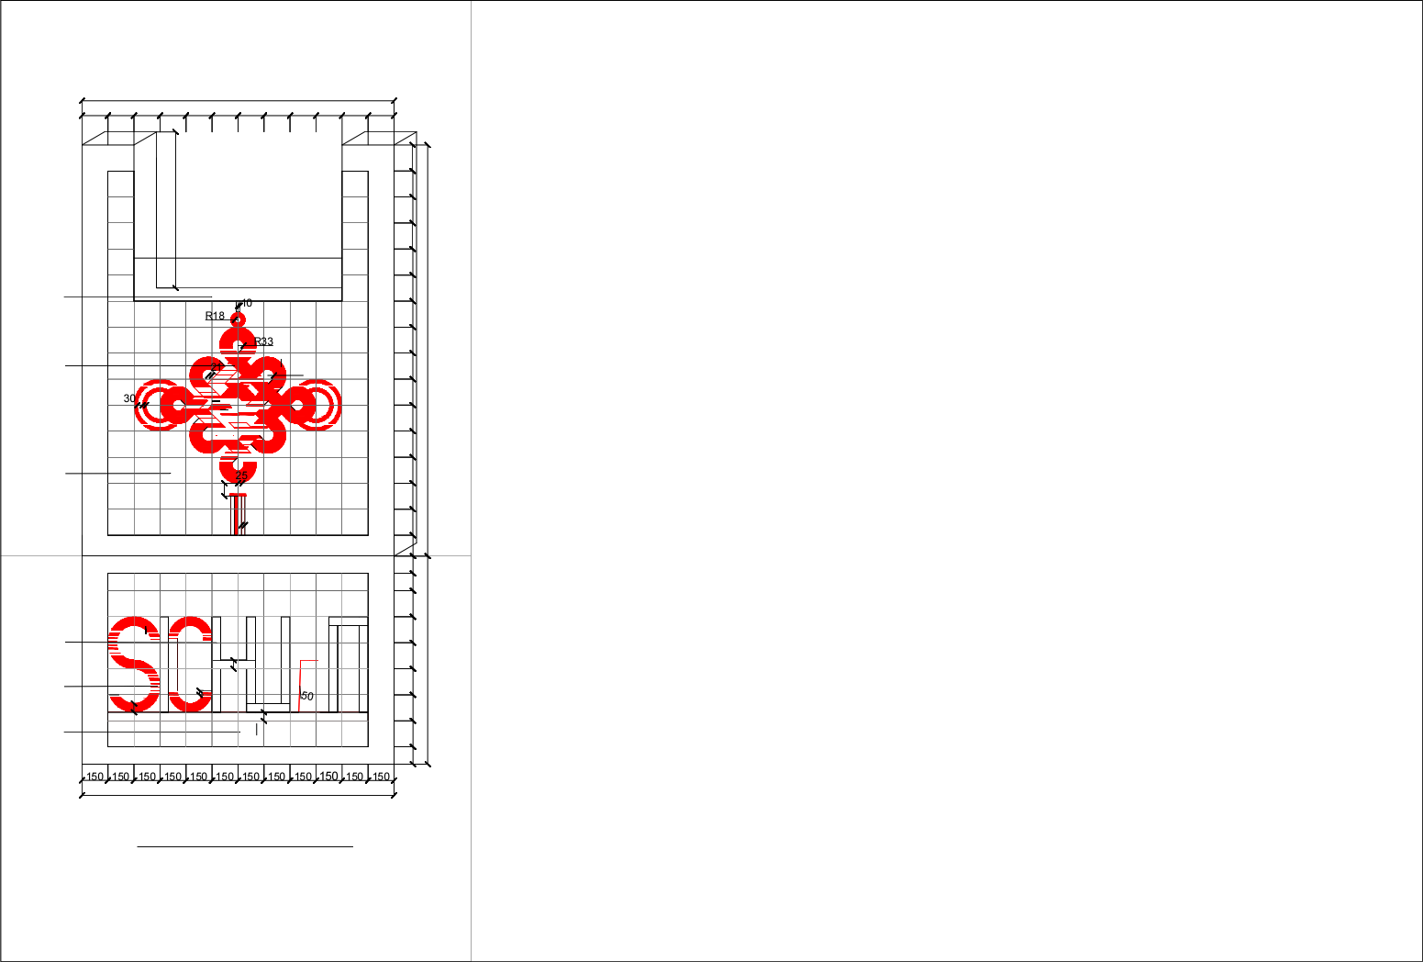

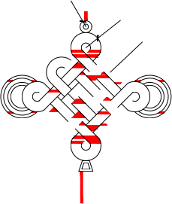

R106
R107
R100
R125
50
900
25
75
50
50
100 150 150 150 150 150 150 100100120 150 150 150 150 150 150 150 150 150 150 150 150 150 150 150
1200 2370
R150
R42
70
R37
1800
150 150 150 150 150 150 150 150 150 150 150 150

墙面
1200
红色瓷砖
白色瓷砖
20
白色瓷砖
20
1800
地面
六级难度:图案复杂~直线/斜线/多层圆、弧切割
黑色瓷砖

红色瓷砖

白色瓷砖
墙地面示意图 1：20

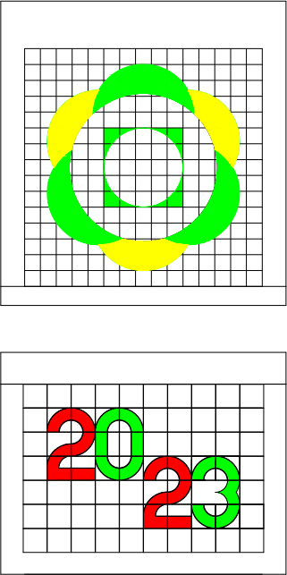  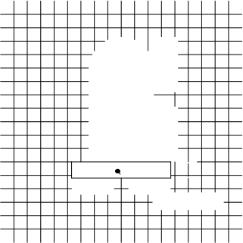  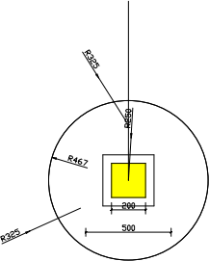    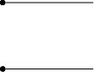  墙面：  黄色瓷砖  绿色瓷砖 |  |  |  |  | 墙面： |  |  | 墙面： | 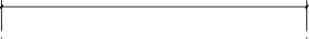  白色瓷砖
  
  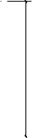
  面贴马赛克
 |  |  |  |  |  | 白色瓷砖  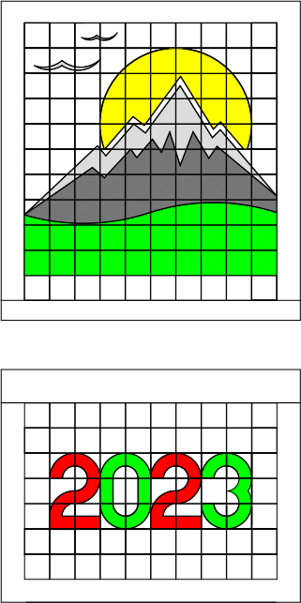  黄色瓷砖 灰色瓷砖 深灰色瓷砖  绿色瓷砖 |  | 墙面：
地面： |  |  |  | 白色瓷砖  绿色瓷砖  红色瓷砖 | 地面：  白色瓷砖  绿色瓷砖  红色瓷砖 |  |  |     地面：  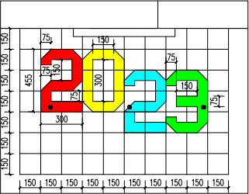  红色瓷砖 蓝色瓷砖 绿色瓷砖  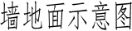
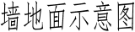 |  |  |  |  | 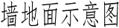
二级难度

墙面： | 白色瓷砖 | 绿色瓷砖 |  | 墙面： | 白色瓷砖 | 绿色瓷砖  黑色瓷砖  红色瓷砖 |  | 墙面：  黄色瓷砖  蓝色瓷砖 绿色瓷砖  灰色瓷砖 | 白色瓷砖 |  | 黄色瓷砖
墙面： | 红色瓷砖  黑色瓷砖
地面： 地面： 地面：
白色瓷砖  绿色瓷砖  红色瓷砖 |  |  |  |  | 白色瓷砖  绿色瓷砖  红色瓷砖 |  |  |  |  | 白色瓷砖  绿色瓷砖  红色瓷砖
三级难度

墙面： | 白色瓷砖 | 绿色瓷砖 | 墙面： 墙面：  绿色瓷砖 蓝色瓷砖
红色瓷砖  黑色瓷砖 |  |  |  | 黄色瓷砖  红色瓷砖 |  | 红色瓷砖  黄色瓷砖
黄色瓷砖

地面： 地面： 地面：
黄色瓷砖  绿色瓷砖 |  |  |  | 白色瓷砖  绿色瓷砖  红色瓷砖 |  |  | 白色瓷砖  蓝色瓷砖  红色瓷砖
四级难度

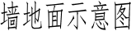
绿色瓷砖
墙面：
墙面：
白色瓷砖
黑色瓷砖
红色瓷砖

地面：
地面：

红色瓷砖 黄色瓷砖 绿色瓷砖

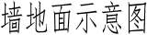

五级难度

墙面：

地面：

六级难度

